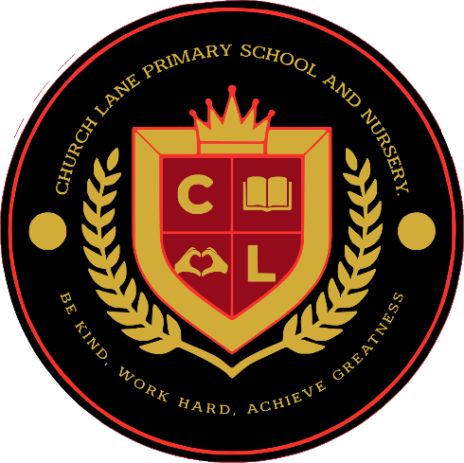

Church Lane Primary School & Nursery

Early Years Packed Lunch Policy

Introduction – Why and How Children Need to Eat Well
At Church lane Primary School & Nursery, we are dedicated to providing a nurturing and healthy environment for all our children. It is our responsibility to ensure that children learn, develop well and are kept healthy and safe in accordance with the Early Years Statutory Framework. A key part of this is ensuring that the food and drinks children consume meet high standards of nutrition and safety. Our packed lunch policy is in line with the DfE Early Years Foundation Stage Nutrition guidance, published in April 2025.
By following this guidance, families can embed healthy eating habits in their children from an early age, laying the foundation for a lifetime of good health.
We know that across Lincolnshire, rates of childhood overweight, obesity and dental decay are higher than the regional and national average. Over a fifth of children are overweight when they reach primary school. Type II diabetes and other diet related conditions are now seen in some overweight children. Many young children suffer from poor dental health and cases of rickets are becoming more frequent. A poor diet also puts children at risk of iron deficiency, which is linked to slower intellectual development and poor behaviour.
We are committed to demonstrating consistent messages about healthy eating, and we believe that a healthy lifestyle should be encouraged at all times. Our aim is to ensure that all aspects of food provision, food education and nutrition contribute to the health, educational benefits and wellbeing of our children, their families and the whole community.
For healthy development and growth, children need to eat a wide variety of foods and access a balanced and nutritious diet. We will support your child to develop and maintain a healthy attitude to food.
As an Early Years setting, we are ideally placed to help you influence your child’s diet and contribute significantly to improving their health, wellbeing and education.

Good nutrition is important for children under five to:

- Ensure they get the right amount of energy and nutrients that they need while their bodies are rapidly growing

- Ensuring that they don’t consume too much energy (calories) which may lead to weigh gain or obesity and diet related illnesses in later life

- Encourage them to eat a wide variety of foods and develop good dietary habits for later childhood and beyond

Basic Principles of Nutrition for Young Children

Children should be encouraged to eat a wide variety of foods from the four main groups. It is important to include different textures, which are essential for a child’s development.

For children aged two years and above, the Eatwell Guide (based on government guidance) shows what a balanced diet looks like, either across a single day or a whole week:
The Eatwell Guide - NHS

A healthy, balanced diet is based on the 4 main food groups (fruit and vegetables; potatoes, bread, rice, pasta and other starchy carbohydrates; dairy or dairy alternatives; and beans, pulses, fish, eggs, meat and other proteins). These provide essential nutrients to help children grow and develop.

The Early Years Foundation Stage Nutrition Guidance provides lots of information about which foods to provide, limit and avoid in your child’s diet. Please use these guidelines as the basis for your child’s healthy packed lunch:
Early Years Foundation Stage nutrition guidance

In line with the guidance, please do not include the following items in your child’s packed lunch as they are high in saturated fat, salt and/or sugar and do not form part of a balanced nutritious diet:
- Sugary drinks
- Foods containing artificial sweeteners (they encourage children to develop a taste for sweet foods)
- Cakes and pastries (e.g. pain au chocolat)
- Crisps
- Chocolate spread, chocolate coated biscuits, chocolate bars or sweets
- Processed meat products
- Sweetened yoghurts
- Popcorn
- Items containing nuts are not allowed in nursery as they can trigger a severe allergic reaction in some children
- Leftover takeaway/fast food

Water and milk are the only permitted drinks at nursery. Water is readily available throughout the day.

As we have an obligation to ensure our children are provided with balanced and nutritious meals, we will monitor packed lunches to ensure they meet our policy. If packed lunches don’t meet our guidelines, we will send a leaflet home in your child’s packed lunch box and discuss this with you. We can provide suggestions for alternative items if needed.

Please consider the number of items included in your child’s packed lunch and portion sizes. Information on this is available in this guidance:
Early Years Foundation Stage nutrition guidance
As well as the cost implication for families, offering too many items can overwhelm your child, reduce the number of foods they will eat, therefore exacerbating fussy or selective eating.

Allergens and Food Safety

Parents/carers must notify us of any special dietary requirements, food allergies and/or intolerances before your child starts nursery and continue to update us of any changes. This will enable us to make sure all staff are aware of your child’s needs and develop an appropriate allergy action plan, with the support of a healthcare professional if needed.

Please ensure all food provided from home is prepared safely to avoid choking hazards. Children can choke on any food, but it is important to take steps to reduce the risk. Here is some useful information to help you:
Food preparation:
- remove any stones and pips from fruit before serving
- cut small round foods, like grapes, strawberries and cherry tomatoes, lengthways and into quarters
- cut large fruits like melon, and hard fruit or vegetables like raw apple and carrot into slices instead of small chunks
- do not offer raisins as a snack to children under 12 months – although these can be chopped up as part of a meal
- soften hard fruit and vegetables (such as carrot and apple) and remove the skins when first given to babies from around 6 months
- sausages should be avoided due to their high salt content, but if offered to children these should be cut into thin strips rather than chunks and remove the skins
- remove bones from meat or fish
- do not give whole nuts to children under five years old
- do not give whole seeds to children under five years old
- cut cheese into strips rather than chunks
- white bread can form a doughy ball in the throat, consider wholemeal or toasted bread and for very young children cut all types of bread into strips
- do not give popcorn as a snack
- do not give children marshmallows or jelly cubes from a packet either to eat or as part of messy play activities as they can get stuck in the throat
- do not give children hard sweets

As we do not have facilities to refrigerate packed lunches brought from home, we recommend that they are sent in insulated lunch bags or contain ice packs to ensure food is kept cool, particularly during the summer months. We are unable to cool or heat food, so please ensure all packed lunch items are ready to eat.

Date implemented: Sept 2026
Review Date: Sept 2027

